March 1, 2026

SUBJECT: Gift Certificates Supporting the Bacon Bash

We are delighted to invite you to support the 2026 Bacon Bash – A Bacon, Beer & Bourbon Affair, taking place on Thursday, May 21, 2026, at the beautiful Virginia Living Museum.
We are seeking donations of gift cards or gift certificates valued at $25 or more to feature in our popular “Gift Tree.” Guests will purchase a pull from the tree to reveal their prize, with all proceeds benefiting local charities. Because the event date is late May 2026, card or certificate expiration should be 31 December 2026 or later.
You may also contribute products or services valued at $25 or more. For example:
- A car wash might offer a month of unlimited washes (valued at $40)
- A restaurant could provide a “Dinner for Two” (one appetizer, two entrées, and dessert valued at $50)
This highly anticipated annual event attracts more than 600 guests for an evening of camaraderie, networking, and indulgence in bacon-inspired culinary creations from the region’s top restaurants. Hosted by the Warwick at City Center Rotary Club, Bacon Bash celebrates local businesses while raising funds for impactful service projects across our community.
Guests will enjoy:
• Live music and entertainment
• A spirited bourbon challenge featuring local bartenders
• Craft beer from Virginia’s finest microbreweries
• Wine and a selection of non-alcoholic beverages
• The opportunity to vote for the People’s Choice Award among participating restaurants
Since its inception in 2014, Bacon Bash has raised over $262,000, benefiting a wide range of local organizations.
Names of all gift card donors will be displayed at the event, providing a meaningful opportunity to highlight your business while supporting these vital causes.
Thank you for your commitment to community service and for considering a partnership that will help make Bacon Bash 2026 an unforgettable evening!
Warm regards,
Rusty Sprouse
Warwick @ City Center Rotary Club

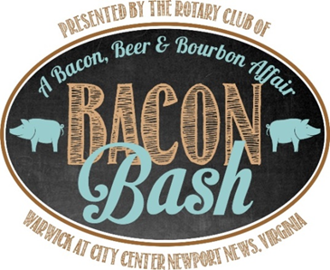
Thursday, May 21, 2026
at the
Virginia Living Museum
Gift Card/Certificate Agreement
Vendor Name:
Address:
City: State: Zip Code: _________
Biz Contact Name:
Phone: E-mail:
Company Website:
My Rotary contact person is: __________________________
Gift Card or Gift Certificate Information
Gift Card for Value
____________________________________ $ ________
____________________________________ $ ________
____________________________________ $ ________
____________________________________ $ ________

Submission Instructions

Gift Cards Enclosed for $_________ Mail to:
Warwick @ City Center Rotary Club
PO Box 120472, Newport News, VA 23612
Memo line: Bacon Bash
Or give to Rotary Contact Person listed above.
Please contact Jennifer Turlington at 757-534-7402 if you have any questions.
Gift Card/Gift Certificate deadline: 05/01/2026

